**Assignment-2**

**Name of Student: Mayuresh Nitin Chavan Subject: Cloud Computing**

**Batch: B2 Branch: AI&DS A PRN:12220159 Roll No: 23**

**Problem Statement:**

Installing two Virtual Machines on VirtualBox and let them communicate with each other

**Establishing network setting:**

**VM1:**

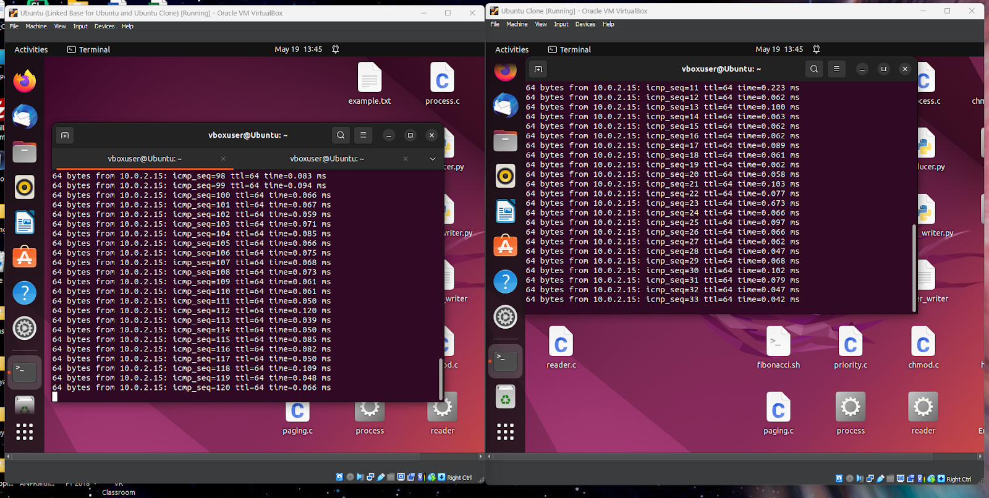

**VM2:**

